Ambarvale Public School
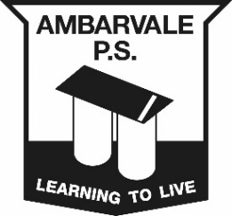
Uniform Pricelist and Order form

Parent Name: __________________________________________________________
Contact Number: _______________________________________________________
Student Name: _________________________________________________________
Class: _________________________________________________________________

Girls Uniform
Item | Price | Size | Quantity | Cost
Dresses Size 4-16 | $38.00
School shirt | $26.00
Skorts | $16.00
Sport Shorts | $18.00
Boys Uniform
Item | Price | Size | Quantity | Cost
School shirt | $26.00
Everyday Shorts | $16.00
Sports Shorts | $18.00
Additional Items
Item | Price | Size | Quantity | Cost
Cap | $13.00
Sports Socks | $5.00
Library Bags | $10.00
Fleece Hoodies | $30.00
Microfibre Jacket | $35.00
Microfibre Pants | $25.00
Tracksuit | $58.00

Starter Pack 1 | Starter Pack 2 | Starter Pack 3 | All Packs $180
Item | Item | Item | Size | Cost
3 Shirts | 2 Dresses | 1 Dress
3 Shorts/Skorts | 1 Shirt | 2 Shirts
1 Sports Shorts | 1 Sports Shorts | 1 Sports Shorts
1 Microfibre Jacket | 1 Microfibre Jacket | 1 Shorts/Skirt
1 Microfibre Pants | 1 Microfibre Pants | 1 Microfibre Jacket
1 Cap | 1 Cap | 1 Microfibre Pants
 |  | 1 Cap
 |  |  | Total=

Uniform Shop Open | Everyday | 8.30am - 3.00pm

Payment Methods Accepted | Cash
 | Eftpos
 | Layby Available | 20% deposit and payable over 8 weeks

03/09/2018

